***E-commerce Application***

***TEAM-7***

1. ***AMAN SINGAL-180030004***
2. ***HIMANSHU-180020013***
3. ***ADITYA RAJ-180010004***

**OVERVIEW :**

A e-commerce based website is developed which facilitates the transactions and relevant features for both buyers and sellers.

1. Firstly, seller and buyer registers with the application giving a valid username and password.
2. Login web page: Once the registration is done, the seller can login and go for adding various products and the buyer can login and to go to different categories to search for the desired product, shopping various product available at the moment.
3. Buyer/Seller first have to add the product in cart and only then she can buy the product.
4. The user need to first enter the payment info.
5. The user can then complete the transaction and that much money will be deducted from her bank account.

**PROGRAMMING LANGUAGES/TOOLS:**

**1.Bootstrap 4 :-** For Obtaining Classes And Divisions For Styling.

**2.Html: -** For Adding Tags And Maintaining The Overall Layout.

**3.Php:-** For Handling Back-End Requirements Of The Website.

**4.Mysql:-** For Maintaining Database To Store Information.

**IMPLEMENTATION:**

1. **FRONT END**: weare using Bootstrap 4 and Html. Following are the files used for the purpose.

* **Glyphicon.html:-** Used for inserting symbols and icons.
* **Jumborton.css:-** Used for styling title.
* Other features of Bootstrap 4 has been added using CDN method which requires attaching CSS stylesheet links in the HEAD tag of .html/php page.

1. **BACK END:** We are using php for implementation for back end part.Following are the files used for the purpose.

* **main.php -** Is the homepage file. Begin from this.
* **PHPMailer.php -** Is included for mailing facility(not used as of now).
* **config.php -** sets up the connection to database.
* **signin.php -** Used while signing in.
* **signup.php -** Used for signing up user.
* **profile.php -** Displays info about the user details.
* **logout.php -** Used for logging out.
* **search.php -** Search for products available(basic functioning only included as of now, keyword matching).
* **electronics.php -** Displays product details under this category.
* **addtocart.php -** Adds the product to user cart.
* **buy.php -** File for buying the product.
* **addproduct.php -** File used by seller for adding the product to the respective category.

1. **DATABASES:** Following are the databases used for this purpose:-

>Table "userinfo" with fields user_name(varchar(100)), user_email(varchar(255)), user_password(int(11)), user_activation_code(varchar(80)), user_email_status(vaarchar(15)), user_mobile_number(int(10)), user_address(varchar(70)), user_role(varchar(30)).

>Table "cardverify" with fields user_email(varchar(255)), user_email_verification(varchar(255)).

>Table "cart" with fields useremail(varchar(255)), productname(varchar(255)), price(int(7)), companyname(varchar(255)).

>Table "electronics" with fields useremail(varchar(255)),productname(varchar(255)),companyname(varchar(255)), features(varchar(255)), quantity(int(6)), image(longblob), price(int(7)), rownumber(int(7)).

>Table "payment" with fields nameoncard(varchar(255)), cardno(bigint(16)), validity(date), cvv(int(3)), pin(int(4)), balance(int(11)).

1. **Buyer Flow**

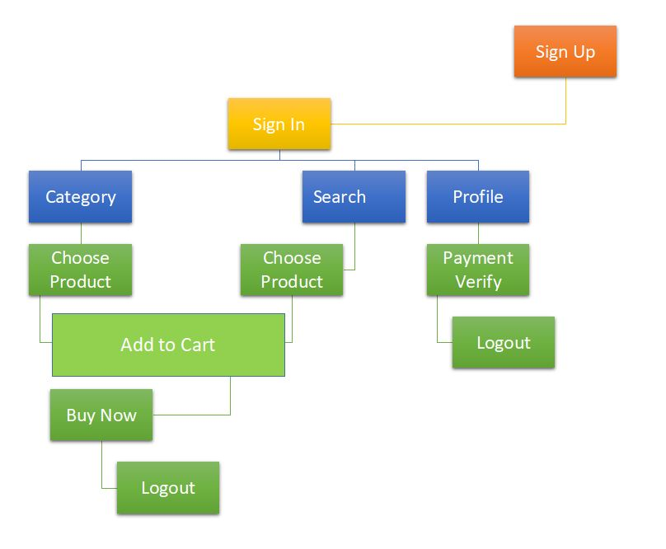

1. **Seller Flow**

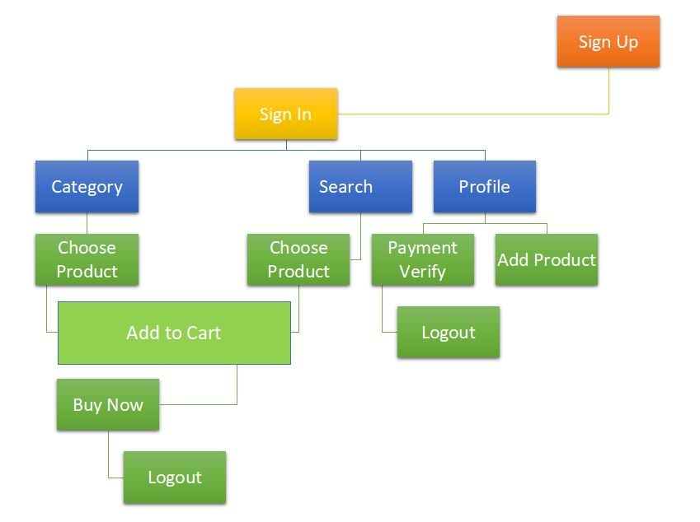

1. **GETTING STARTED**
2. Download the zip folder and keep it in a place where your apache server can operate upon

it(if using xampp server keep in htdocs folder).

1. Extract it in the same directory.

/**/ Don't forget to start your server both Apache and MySQL if using Xampp.**

1. Don't change the names of any files or folders.
2. Now make the above tables in database named ‘users’ in phpmyadmin feature of localhost.

**HOW TO USE OUR WEBSITE:**

* As soon as you open our website(**go to main.php**), to see and buy the products sign up if you are new user or sign in if you are already registered.
* You can register either as seller or a buyer and fill the credentials accordingly including card details.If you are new user after signing up if you have to sign in. Two user can’t have same email id.
* You can also check your profile by clicking on profile button.
* If you login as a buyer now,you can search desire product by clicking on search button and you get various product available on our website.you can add product to your cart by using add to cart button and from the cart you can select buy now option either from cart or directly .
* If the card credentials will be verified correctly and there will be sufficient balance in your account you will be able to buy the product .
* You can also search product category wise . You can do so by clicking on category button on the top left corner , and you can select desired category from the drop down menu.
* If you login as a seller ,you can add various product by using our add product button.for add product you have to fill the credential which is quantity,price and features etc.